 | 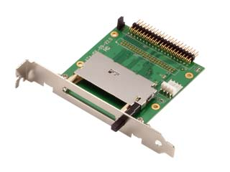

CompactFlash to IDE Card Drive

Model No.: ID011C-R

ID011C-R is IDE Compact Flash adapter board. It provides a convenient & easy way application of Compact Flash to IDE Device

Features：
- 2.5” form factor
- Supports Compact Flash Type I / II (Micro Drive)
- Optional 40 pins IDE and 4 pins power connectors or 44 pins Connector
- Optional LED possible
- One Compact Flash socket w/ejector
- Dimensions: 79.7mm x 70mm x 10.7mm
- Screw bracket of Rear slot
- Master/Slave optional

- Support DMA mode

