23 in 1 USB 2.0 Card Reader Writer
CS2RE23850B00  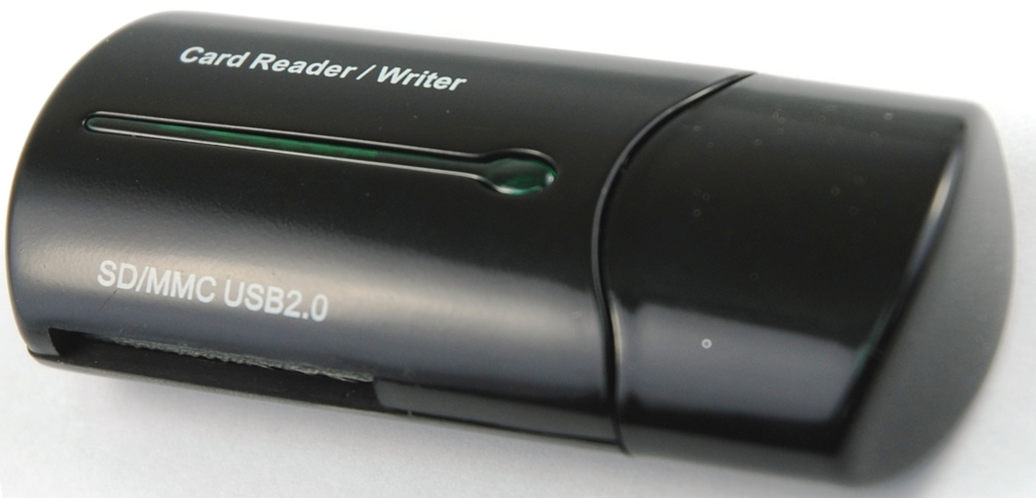 | Carton/ 100pcs  56(L)X39(W)X31(H)cm  8.5KG(GW)  7.5KG(NW)  2.4 CUFT
PRODUCT SIZE(L*W*H)mm
67.5*28.3*15.2
Features :
- Compliant with USB Version 2.0.
- Support 23 types of memory cards.
- MMC/MMC II/ULTRA MMC/DV MMC/RS MMC/HS MMC/HS RS MMC/RS MMC II/ ULTRA RS MMC/DV RS MMC/SD/ MINI SD/ULTRA SD/DV SD/HS Mini SD/ Extreme SD/Extreme III SD/Ultra II SD/SD-Ultra-X/Ultra speed SD/SD PRO/ SD Elite Pro/HS SD Support
- Support SDHC memory card
- Support Plug & Play and Hot-Swap function.
- Support auto-detecting slot while card inserted.
- High transfer rate with USB interface:
Full speed up to 480MBps.
- O/S support Windows 98/98 SE/ME/2000/XP/VISTA
Mac OS 10.1.2.3 or later, and Linux Kernal 2.4.0 or later.

