鼎陶親密罐系列產品規格表

產品名稱 | 規格 | 容 量 | 外徑/外高(公分)
親蜜罐 | 一斤(大) | 2.35L | 13x26 cm
親蜜罐 | 半斤(中) | 1.3L | 10.5x20 cm
親密罐 | 紅茶二兩(小) | 0.6L | 8.5x17 cm
親蜜罐 | 四兩(小) | 0.57L | 8.5x14 cm
親蜜罐 | 二兩(特小) | 0.29L | 7.5x9.5 cm
親密罐 | 一兩(迷你小) | 0.12L | 6x7.4 cm

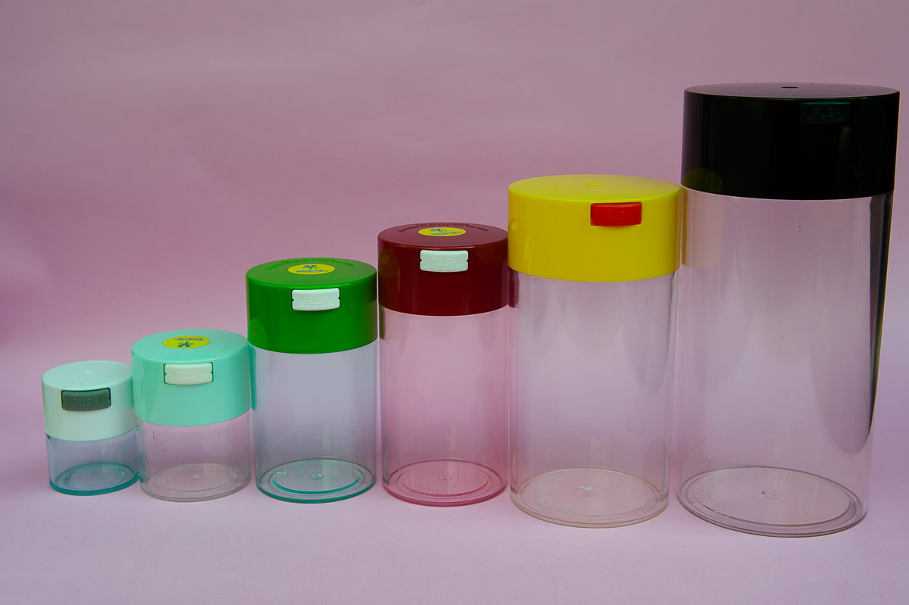

DIING TAUR CO., LTD.
No. 392, Sihu Rd. Dali Dist, Taichung City 41263, Taiwan (R.O.C)
Tel: 886-4-24926895 Fax: 886-4-24926885
E-mail：chinme89@yahoo.com.tw

MODEL | CAPACITY | DIAMETER | HEIGHT | SIZE
ChinMe Bottle | 2.35 L | 13CM | 26CM | BIG
ChinMe Bottle | 1.3 L | 10.5CM | 20CM | MIDDLE
ChinMe Bottle | 0.6 L | 8.5CM | 17CM | SMALL 1
ChinMe Bottle | 0.57 L | 8.5CM | 14CM | SMALL 2
ChinMe Bottle | 0.29 L | 7.5CM | 9.5CM | SPECIAL SMALL
ChinMe Bottle | 0.12L | 6CM | 7.4CM | MINI
P.S. you can change any color you request if your order over 1500 bottles for the size big, middle
Also the small and special small or mini one the order should be over 2000 bottles.

